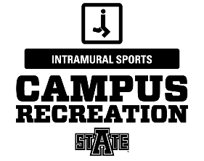
Arkansas State University
Intramural Sports
Ultimate Football Rules

Game Format:
- Games will consist of two (2) twelve (12) minute halves with a running clock.
- Teams will consist of 4 players. A team may start a game with a minimum of 3 players. If a team does not have the minimum number of players AT GAME TIME, then it will result in a forfeit.
- Teams do not have time-outs.
- The winner of the coin toss shall have the option of receiving, or defending a goal, the losing team will chose the remaining option.
- The team with first possession will begin at the designated “goal line” and will have four (4) passes of the ball to reach their opponent’s designated “goal line.”
- The four (4) passes may be forward or backward. Once a pass and catch has been made, the player with possession of the ball is only allowed to take one step before making the next pass. The player will have five (5) seconds to make the next pass. The player in possession may rotate on their “pivot foot” when attempting the next pass
- If a pass is not caught, it will result in a turnover to the opposing team at the spot of the ball.
- If a team fails to reach the “goal line” in four (4) passes, a turnover at the current spot of the ball will result.
- “Touchdowns” are worth one (1) point. There will be no extra point tries.
- Overtime will be “sudden death.” The first team to score will win. A coin toss will be administered to decide who has first possession.
- Mercy Rule: The mercy rule will be in effect as follows:
  - If a team is ahead by 20 points at half time the game shall be called.
  - If a team is ahead by 15 points with 6 minutes left in the second half the game shall be called.
  - If a team is ahead by 10 points at the 2 minute mark the game shall be called.
Fouls:
- This is a non-contact sport. Contact will not be tolerated.
- If the passer is fouled in the act of throwing and the pass is completed, the foul is automatically declined and play continues without interruption.
- If the defender is fouled in the act of throwing and the pass is not completed, play continues without interruption.
- Violations consist of traveling with the ball, or attempting to strip then ball.
- Fouls and violations result in a change of possession.

